27 March 2023
The New Golf GTI Unveiled with IQ.DRIVE

Press contact
Shazmyir Rahman
Senior Executive, PR & Social Media,
Tel: 016 – 972 2189
E: shazmyir.rahman@vw.com.my
Click to subscribe to our social media channels
More information at:
Volkswagen Malaysia website
Volkswagen newsroom

- Advanced safety features for a safer and more comfortable journey
- Recommended retail price of RM244,990
- DNA of the GTI has been improved and can be seen in both the exterior and interior details

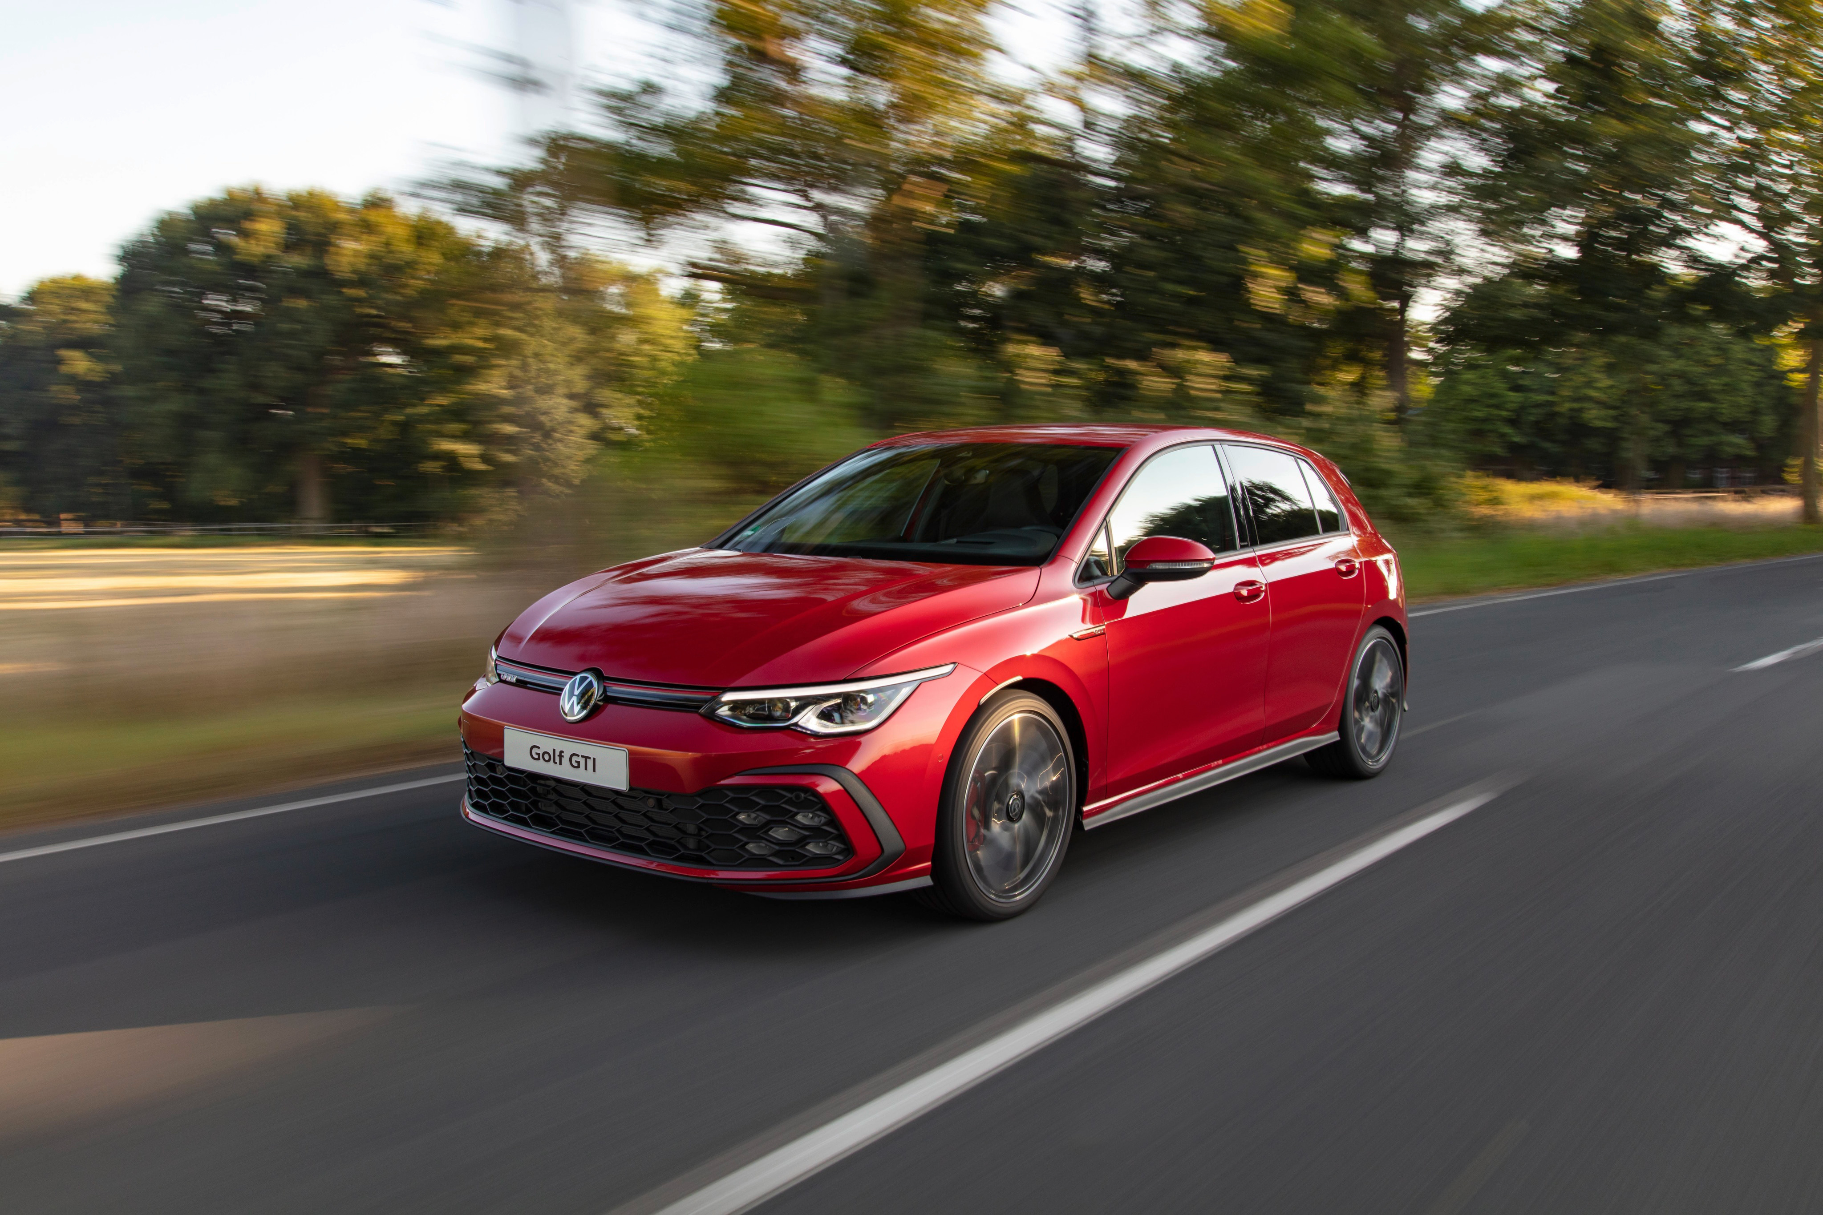

KUALA LUMPUR – Volkswagen Passenger Cars Malaysia (VPCM) today unveiled the refreshed Golf GTI equipped with IQ.DRIVE, an innovative Driver Assistance System (DAS). The interior also offers updated new features such as wireless charging and embroidered GTI logo on the driver and front passenger seats. The new Golf now comes with the recommended retail price of RM244,990.

The IQ.DRIVE system is designed to assist drivers in making their journeys safer and more comfortable. The advanced safety features consist of Travel Assist and Adaptive Cruise Control (ACC) which uses radar and various sensors to detect vehicles ahead, as well as Side Assist which acts as an active blind spot monitor, and Rear Cross Traffic Alert which warns drivers of potential danger when the reverse gear is engaged.

The Golf GTI also comes with Front Assist which is the Autonomous Emergency Braking (AEB) feature that uses a radar sensor integrated into the front of the vehicle to continuously monitor the distance to the vehicles ahead. In addition to detecting vehicles, the latest version of Front Assist also detects pedestrians and cyclists crossing the road.

The Lane Assist function on the other hand ensures that the driver stays in lane, using its camera-based lane-keeping assistant. If the vehicle deviates towards another lane when direction indicators are operated by the driver, the system automatically intervenes by steering back into line. In addition, there is also an Adaptive Lane Guidance function that keeps the car within its own lane on an ideal line learned from the driver’s driving characteristics.
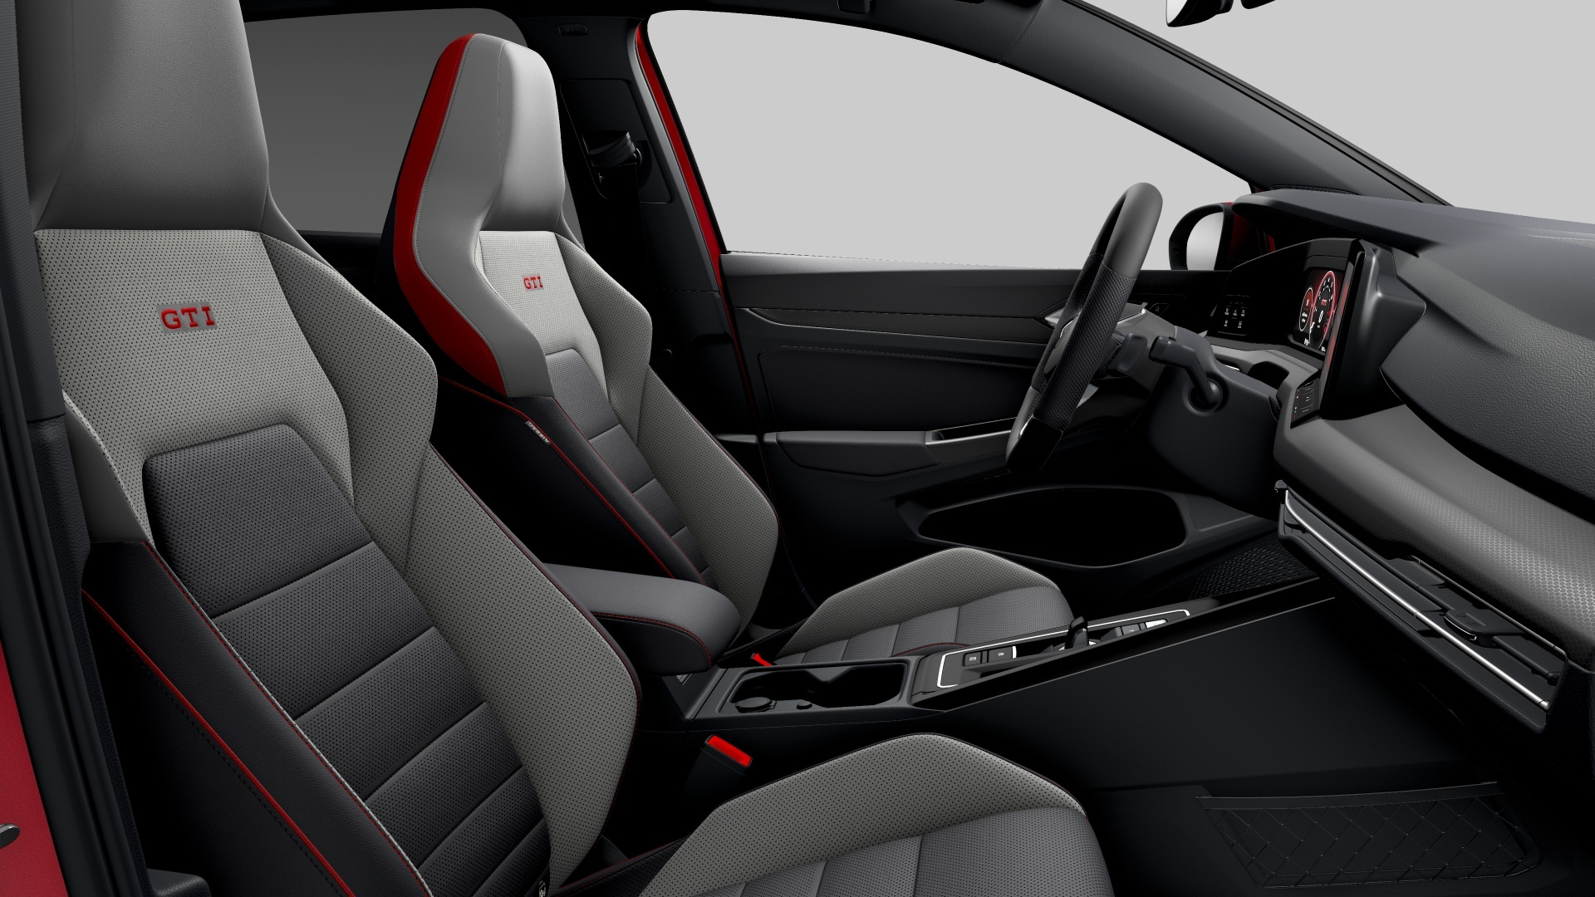
Fondly known as the ultimate hot hatchback, the Golf GTI is also now offered with a host of upgraded interior and exterior features such as new fog lights, electrically heated and adjustable folding mirrors and an additional centre airbag, with 7 airbags in total.

The Golf GTI prioritises exhilaration in every drive, as proven by the turbocharged engine generating a 245PS and 370Nm of torque – promising a thrilling and unforgettable experience coupled with added safety features for the ones behind the wheel.

Erik Winter, Managing Director of VPCM, said the company is committed in enhancing the safety of its cars through advancements in vehicle design and technology, such as the IQ.DRIVE system. “We are always striving to offer our customers the best possible ownership experience. The new safety feature for our latest Golf GTI model is just another example of our commitment to providing our owners with the highest level of safety and performance."

Bookings and test drive arrangements can be made at all authorised Volkswagen dealerships nationwide. For more information, visit https://www.volkswagen.com.my/the-all-new-golf/golfgti

KEY USPS

Design
The Golf GTI is immediately recognisable with its signature honeycomb front grille and red GTI trims. It sports 18” Richmond alloy wheels with red brake callipers, and full LED headlamps and taillights. With its iconic styling, the GTI is sure to turn heads wherever it goes.

Driver’s Workspace
The Driver’s Workspace, an entirely digitalised interior landscape, provides seamless connectivity and convenience.

It welcomes a new-generation 10.25” Digital Cockpit with multiple colour themes and views, including a GTI-specific skin, as well as a multifunction steering wheel with haptic-touch control and heating. An advanced 10” Discover Media infotainment system sits at the centre of the dashboard, offering 3D inbuilt navigation, wireless Apple CarPlay and Android Auto, and seven high-quality speakers.

Voice recognition and voice quality (for phone calls) are seamless, as they can locate the person who is speaking (driver or front passenger) and respond accordingly, for example by identifying which interior zone’s temperature needs adjusting.

Comfort
Expect a visual treat in every ride as the ambient lighting can be linked to driving modes. There are up to 30 colours to choose from, in addition to five pre-set colour modes (Infinity, Eternity, Desire, Euphoria, Vitality), and individualised settings.

A pleasant and comfortable interior environment is further ensured with the 3-zone Climatronic air con. Adjust the temperature with the touch slider or simply through voice control. There are two main modes for the air con – Smart Climate and Classic Climate, and each comes with various helpful functions. The 3-zone Climatronic air con is equipped with Air Care to filter out pollen, spores, and particulates to keep the air clean.

Space and Convenience
The iconic hatchback offers plenty of room for all the family in the interior, whereas its 374-litre of luggage compartment can fit large pieces of sports and recreational equipment.

Another smart feature of the vehicle is that it gives quick entry access by automatically unlocking the doors when vehicle key is within the detection zone. The Golf GTI also comes with Tyre Pressure Loss Indicator to warn when there is loss of tyre pressure.

Safety
Other safety features include ESC (Electronic Stability Control); Post Collision Braking System that prevents a second collision; Electronic Differential Lock (XDS) to improve traction and reduce understeer; six airbags for post-collision protection and more. Get ready to experience superior control and improved handling with the Golf GTI Front Differential Lock. Thanks to its ability to grip the surface better when cornering, this differential lock is perfect for those who seek greater response and control on the road.

Colours
Five colours are available: Kings Red and Atlantic Blue in metallic finishing; Moonstone Grey for non-metallic option; as well as Deep Black and Oryx White with pearl effect at no additional charges.

Price
The new Golf GTI is valued at the recommended retail price of RM244,990 and comes with three years free maintenance, five years unlimited mileage warranty, and five years roadside assistance.

###

SEO/Metatags Keywords
Volkswagen, Volkswagen Malaysia, Volkswagen Golf GTI, IQ. Drive, Harga Volkswagen Golf, Kereta Golf, Volkswagen Golf Price, VW Golf, Volkswagen Golf Dealer
Volkswagen Passenger Cars Malaysia (VPCM) is the official distributor of Volkswagen cars in Malaysia. The Company has long-term aspirations in the country and focuses on growing the business sustainably by maintaining a strategic product portfolio, strengthening dealer network, and enhancing service and parts availability. VPCM is managed by Porsche Holding Salzburg, one of the largest and most successful automotive distributors in Europe. The Salzburg-based company was founded in 1947 and operates today in 29 countries throughout Europe, as well as in Colombia, Chile, China, Malaysia, Singapore, Brunei and Japan.

