17 June 2021
Press contact
Yani Fadzil
Senior Manager, VPCM
Tel: 012 – 212 8977
E: yani.fadzil@vw.com.my

Click to subcribe to our social media channels
More information at:
Volkswagen Malaysia website
Volkswagen newsroom

准备好了吗？新福士伟根Arteon R-Line 4MOTION如今开放订购

- 估计订购价介于RM245,000至RM255,000
- 280PS马力及350Nm扭矩的引擎更强劲使性能无与伦比
- 4MOTION全轮驱动系统使驾控充满动力
- 采用新福士伟根及R厂徽的首款车

吉隆坡 – 福士伟根轿车马来西亚(VPCM)开始接受买者预先订购新Arteon R-Line 4MOTION。在彭亨北根组装的这款车，推介时的售价估计介于RM245,000至RM255,000。

去年在大马面市的Arteon - 一个结合流畅线条与动态驾驶性能的真正精湛车款，为福士伟根旗舰车。彰显时尚风格与速度的新Arteon，车上的新装备包括经过翻新的内装与外观、新科技与新引擎。

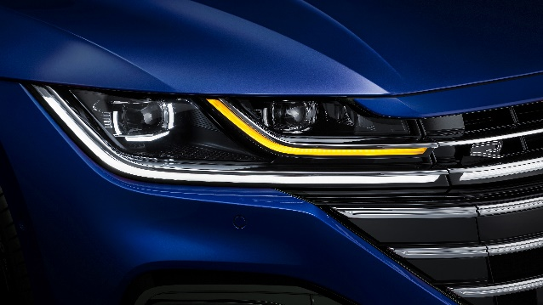
作为采用新福士伟根及R厂徽新的首款车，运动化的装饰进一步凸显了Arteon R-Line的运动你气息。重新设计的前水箱护罩及保险杆更特出，与全LED灯相辅相成。车尾方面，内建连续讯号灯的新LED 3D灯组，使Arteon的斜背式设计更具个性。

Arteon着重行驶性能，动力来自一台2.0L TSI涡轮增压引擎，并与7-速湿离合器直接变速箱(DSG)搭配，最大马力280PS，最大扭矩在5,100至6,500rpm达到350Nm，透过一台4MOTION全轮驱动系统将动力传递至车轮。0-100公里/小时起跑仅需5.6秒。

新车厢的设计旨在带来惊艳 - 重点包括附设Haptic Touch触控键的新方向盘，上有新R厂徽的Nappa Carbon碳纤维真皮ErgoComfort跑车座椅，以及700瓦特12扬声器的Harman Kardon高级音响系统。可采用声音及手势控制的9.2寸大Discover Pro娱乐资讯屏幕，如今支援Apple CarPlay及Android Auto的无线App-Connect。对司机而言，高解析度的数位车舱方面使用及提供指尖客制化功能。安全为全车的重要一环，这方面，新Arteon的司机辅助系统包含Lane Assist维持车道辅助系统、Side Assist侧面辅助系统及Driver Alert司机警示系统。

新Arteon R-Line 4MOTION备有5种车身颜色 - 金属漆的Lapiz Blue蓝宝石、Manganese Grey锰灰及Pyrite Silver砷银，珍珠色则有深黑及剑羚白。

顾客可登录福士伟根线上陈列室eShowroom订购。更多详情可登录https://www.volkswagen.com.my/the-new-arteon-r-line-4motion 浏览Arteon R-Line 4MOTION专页。

###

SEO/Metatags Keywords
Volkswagen, Volkswagen Malaysia, Volkswagen Arteon R-Line, Arteon, R-Line, TSI, VW Arteon 2.0 TSI, DSG, Harman Kardon, 4MOTION All-Wheel Drive, 7-speed DSG

Volkswagen Passenger Cars Malaysia (VPCM) is the official distributor of Volkswagen cars in Malaysia. With long-term business aspirations in the region VPCM’s primary focus is on sales strategies through future products, strengthening the Volkswagen dealer network and service and parts availability. VPCM is managed by European automotive retail specialist, Porsche Holding Salzburg, is one of the largest and most successful automotive distributors in Europe. The Salzburg-based company was founded in 1947 and operates today in 26 markets in Western- and South-eastern Europe, China, and in Colombia and Chile in South America.

